**Employee Attrition Prediction Report**

*Name: Srashti Tiwari*

*Date: April 09, 2024*

**Aim**: This project aims to provide insights into the factors influencing employee attrition and predict which employees are likely to leave the company.

**Problem statement:** Acme Corporation, a leading tech company, is facing a significant challenge with employee turnover. The HR department is concerned about the increasing rate of attrition, as it negatively impacts team dynamics, project continuity, and overall company morale. To address this issue, Acme Corporation wants to leverage data analytics and machine learning to understand the factors influencing employee turnover and predict which employees are likely to leave shortly.

**Dataset:** Acme Corporation has provided historical data on employee demographics, job satisfaction, work environment, performance metrics, and turnover status. This dataset spans the last five years and includes information on employees who have left the company and those who are still currently employed. Following is a sample row*-*



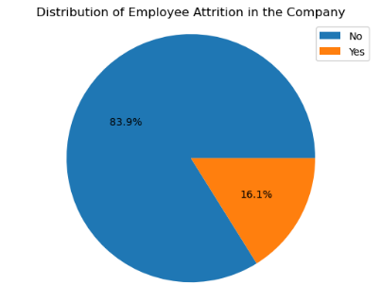

Analysis & Interpretation: The target value Attrition is a categorical variable with the values ‘Yes’ and ‘No.’ The dataset is highly imbalanced and contains significantly more examples for ‘No’ than ‘Yes’.

Below is the PowerBI Dashboard-

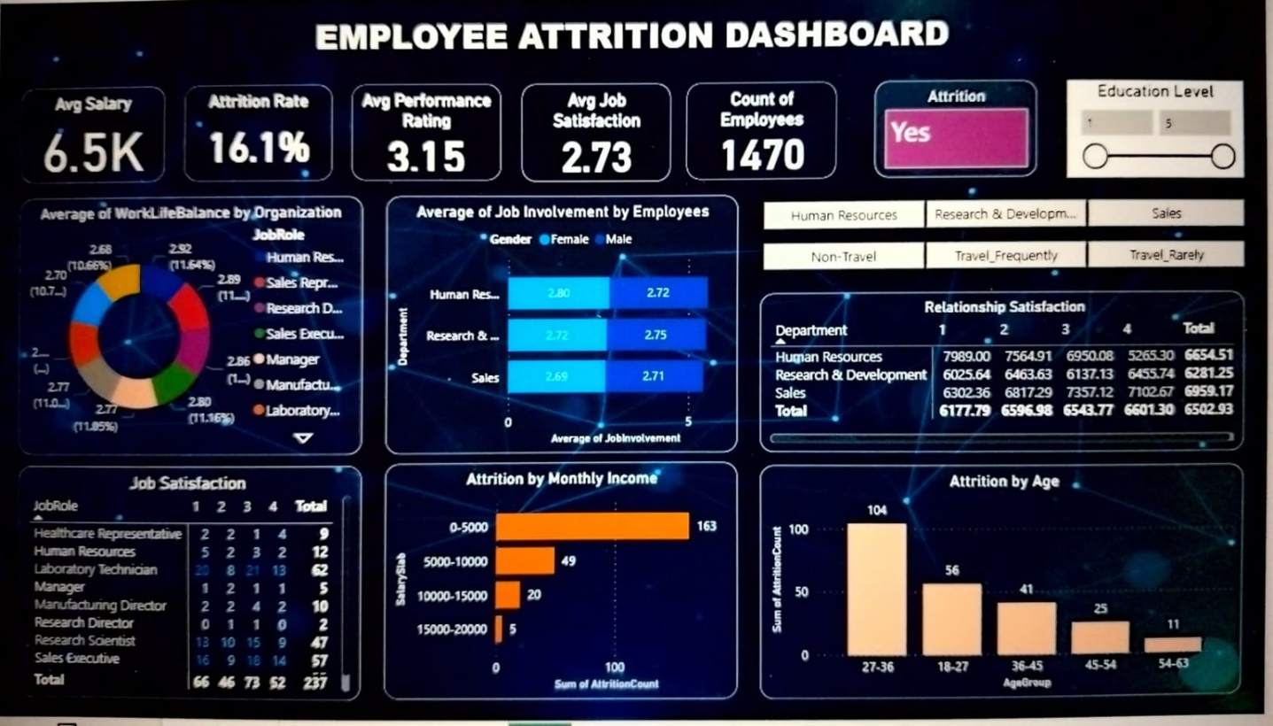

This dashboard gives us the various insights to understand several factors affecting the employee attrition.

The attrition rate is found to be 16.1%.

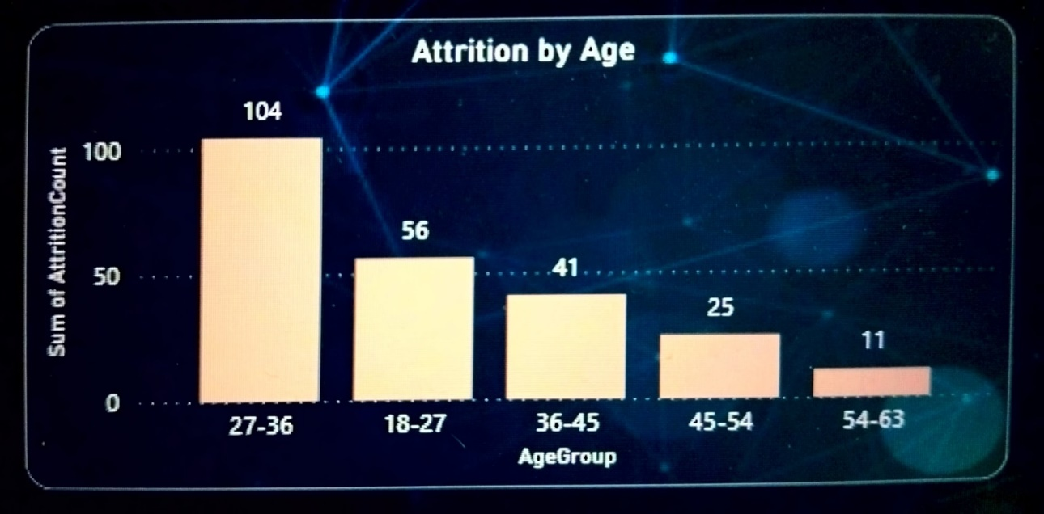It is observed that those employees belonging to the age group of 27 to 36 years are the highest in number to leave the company.

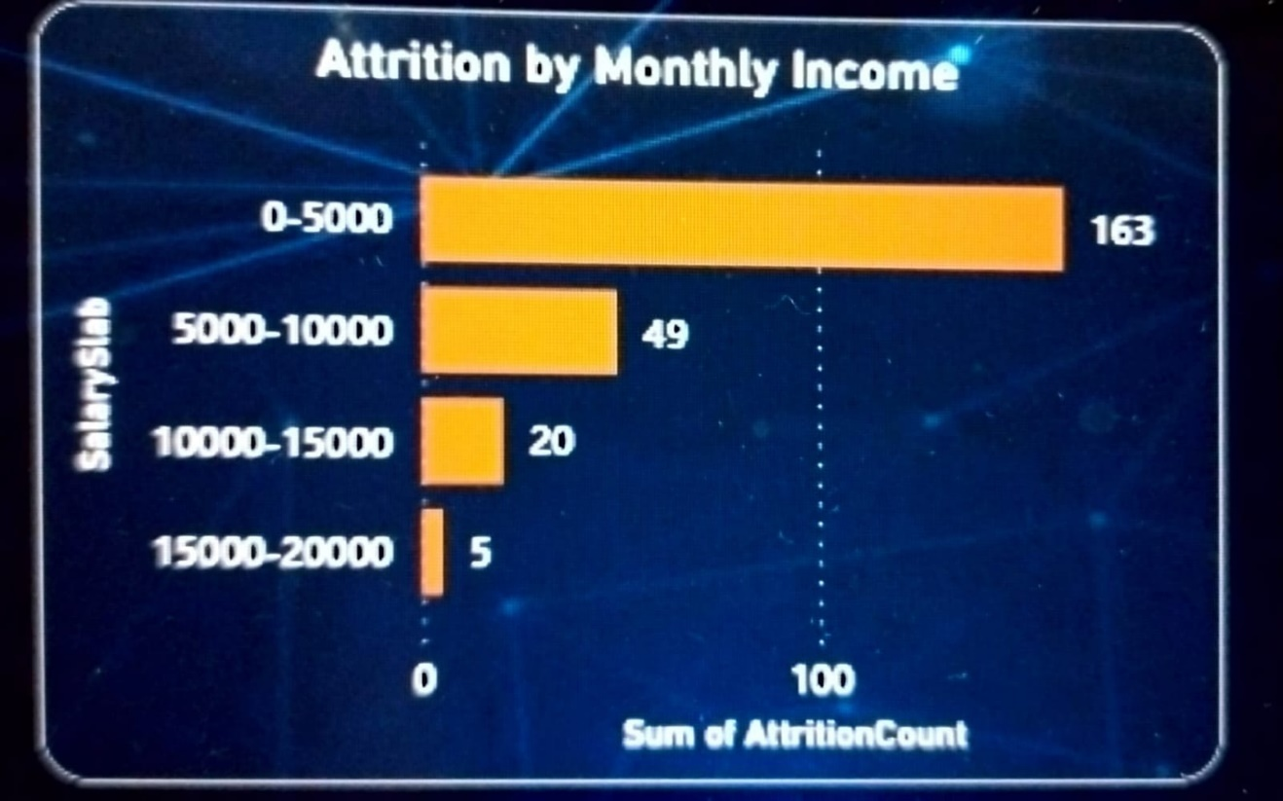

Employees having monthly income below 5k are generally leaving the company. The reason is that their average salary is even less than 6.5k which is the company’s average salary.

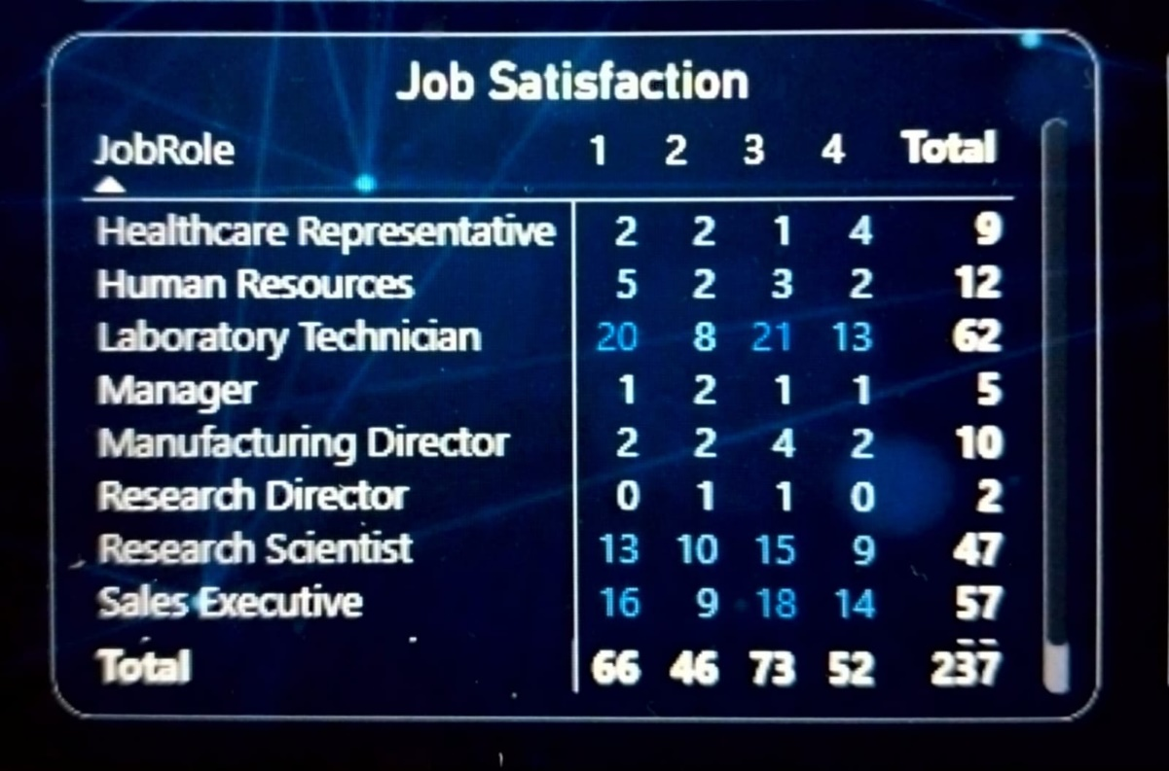From the above table, it is clear that the lab technicians (62) are highest in number to leave the job followed by sales executives (57) and research scientist (47).

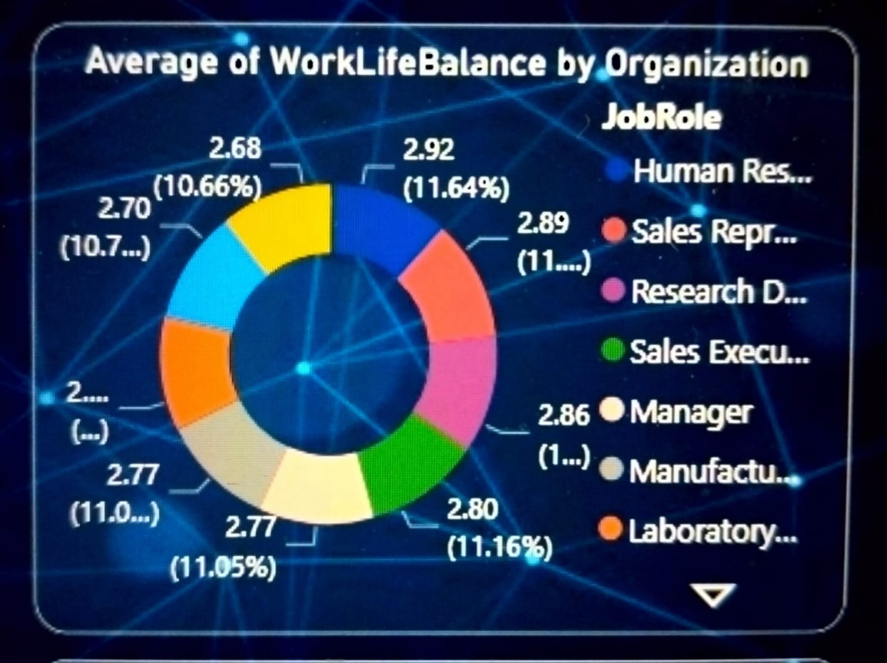

The average work-life balance of employees is nearly the same for all kinds of job roles.

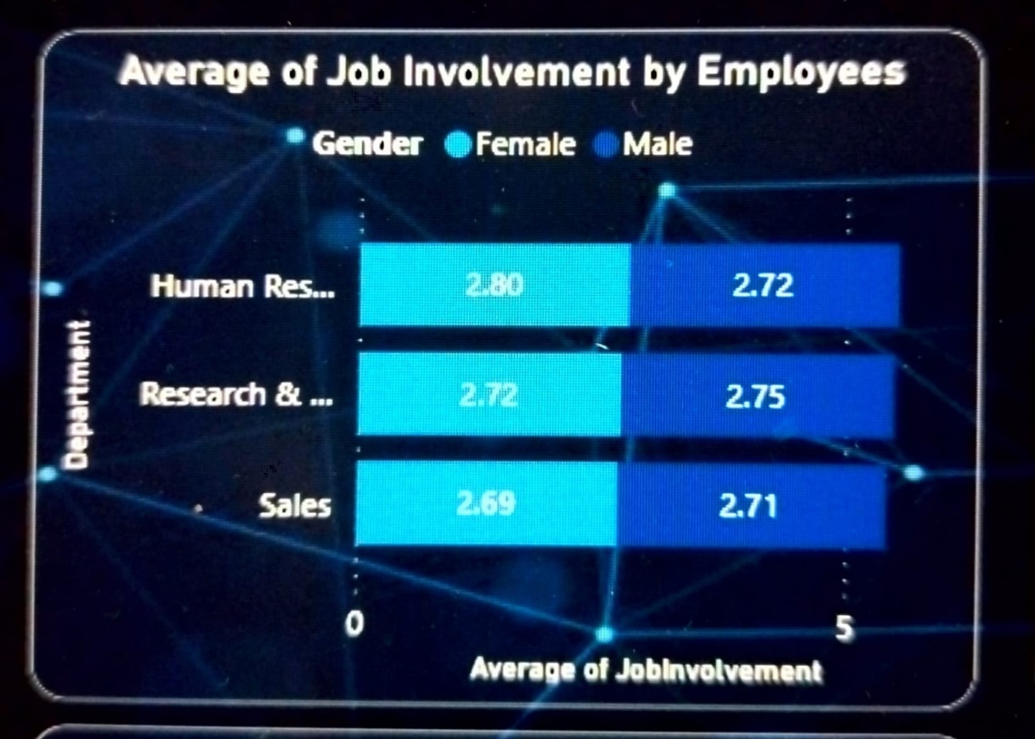

The average job involvement ratio of a female to male is nearly the same for all three departments.

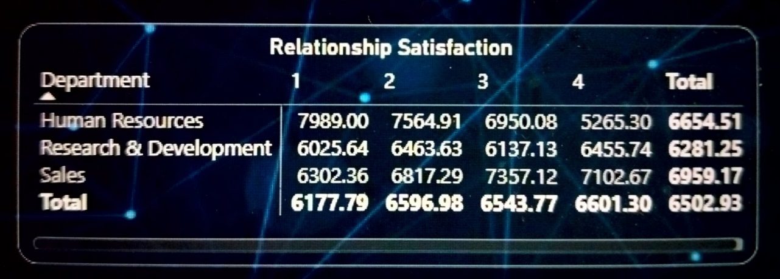

Workplace relationships and interaction have an impact on employee satisfaction and retention. Negative attitudes can lead to isolation and loneliness, which may instigate an employee's desire to resign. The level of satisfaction with relationships at the workplace is highest for the sales department but lowest for the human resource department.